**Sentiment Analysis**

* **Introduction**

Sentiment Analysis, also known as opinion mining, is a branch of Natural Language Processing (NLP) that focuses on determining the sentiment or emotional tone behind a piece of text. It is widely used in analyzing customer reviews, social media posts, survey responses, and other forms of textual data to understand public opinion, customer satisfaction, and trends.

* **How Sentiment Analysis Works**

Sentiment Analysis typically involves the following steps:

1. **Text Preprocessing** – Cleaning the text by removing stop words, punctuation, and special characters.
2. **Tokenization** – Breaking the text into individual words or phrases.
3. **Feature Extraction** – Converting text into a numerical format using techniques like TF (Term Frequency )-IDF (Inverse Document Frequency ) or word embeddings.
4. **Sentiment Classification** – Using machine learning models or lexicon-based methods to classify sentiment into categories like:
   * Positive
   * Negative
   * Normal

* **Examples we collect some customer reviews**

On that basis of sentiment analysis by using python.

|  |  |
| --- | --- |
|  | **Customer Reviews** |
| 1 | The product quality is amazing! I loved it. |
| 2 | Very bad experience, the product broke within a week. |
| 3 | Good value for money. Decent quality for the price. |
| 4 | Terrible customer service! Never buying again. |
| 5 | Satisfied with the purchase. Works as expected. |
| 6 | Worst product ever! Total waste of money. |
| 7 | Delivery was quick, and the packaging was nice. |
| 8 | The material is cheap and feels low-quality. |
| 9 | Exceeded my expectations! Highly recommend. |
| 10 | Not worth the price. Disappointed. |

**We use python code**

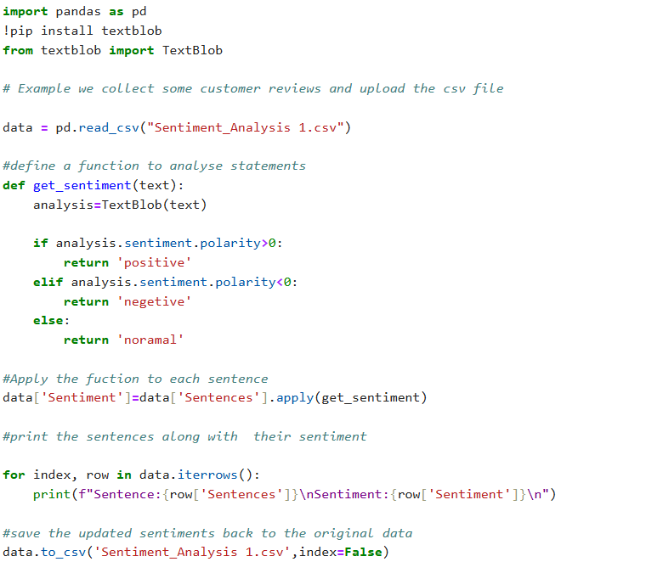

* **Output**

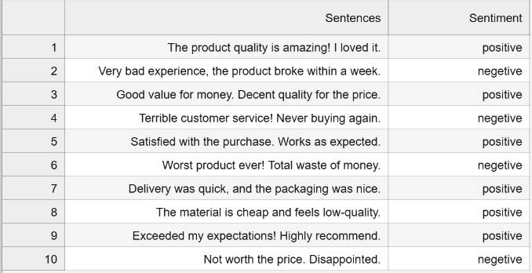

* **Conclusion**

Sentiment Analysis is a powerful tool that helps businesses and organizations make data-driven decisions based on people’s opinions and emotions. With the rise of customer reviews, social media and online reviews, it has become an essential tool in marketing, customer service, and beyond.

* WhatsApp link:

<https://t.ly/xdmUc>

* LinkedIn link:

<https://www.linkedin.com/in/yuvaraj-shivamurti-13929228b?lipi=urn%3Ali%3Apage%3Ad_flagship3_profile_view_base_contact_details%3B5AmZ0FEZRLedpoaOwux5xA%3D%3D>

* GitHub link:

<https://github.com/Yuvaraj-123-shivamurti>